For the calibration you need to have the have the ad8495, the esp32, and a device to measure the temperature. The first thing that is needed is to set up the code for the esp32 so it displays the voltage coming out of the ad8495. 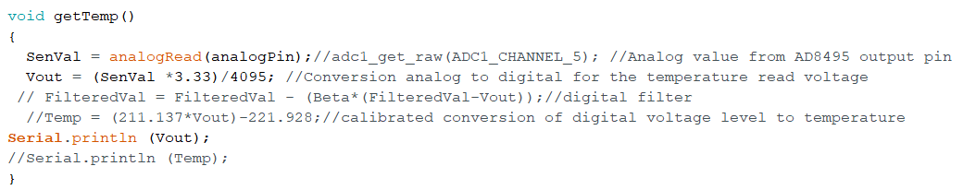

This is set up to display the Vout, the senval is the value that is being read, and needs to be converted and this is the Vout value. The 3.33 is the voltage I got when measuring the voltage input powering the AD8495, and the 4095 is the cycles that the esp32 works on. So when you have this set up you can set up the circuit, you need to use the esp32 as the ground for 2 of the pins, the 3.3v input, and take the output and that gets connected to pin 34, which you can find in the pin layout sheet.

Now on to the calibration, for this you need to take 2 different types of measurements. You need to take a voltage and temperature measurement at 2 different temperature points. One needs to be close to freezing, and the other needs to be close to boiling, and these need to be in C. So you need to take a temperature measurement at almost freezing with the new multimeter, and you will need to take the thermocouple from the AD8495 and have it also in the water but we are using it right now to get the voltage that is coming from it which was stated before. So the multimeter is used to measure the temp and the AD8495 and esp32 are used to show the voltage. To see the serial.println for the Vout you need to have the board hooked up and the code downloaded to the esp32, and to look at it you need to click on tools, the serial monitor and this will show any serialprints.

$$Find the slope:y-y_{1}=m\left(x-x_{1}\right)$$

$$Where y=\operatorname{maximum}{temp. from meter}$$

$$y_{1}=\operatorname{minimum}{temp. from meter}$$

$$x=\operatorname{maximum}{voltage from AD8495}$$

$$x_{1}=\operatorname{minimum}{voltage from AD8495}$$

$m= \frac{\left(y-y_{1}\right)}{\left(x-x_{1}\right)}$

$y=mx+b$

$b=y-mx$

$Temperature=m*V_{out AD8495}+b$

So this is going to be the formula to take the voltage coming from the ad8495 and convert it to temperature. This temperature formula can be plugged back into the code and this is what the temp part of the code should look like then

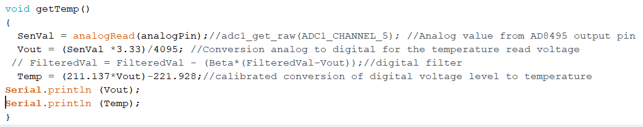

You can check to see if this is correct by downloading this new code to the esp32 and then look at the serial monitor and this should now show the Voltage that is being read and the conversion to temperature from the formula, this can be verified by taking the meter and having it read temp and see if the reading you are getting from the esp32 matches similar to the meters reading.